## MINI PROJECT REPORT

**on**

**FARMER’S GUIDE**

**Submitted in partial fulfilment for the completion of the course**

**Mini Project I in**

**III Semester of B.E.**

**INFORMATION TECHNOLOGY**

**By**

**K.JAISAI (160118737027) phno : 7013071099**

**B.DHANUNJAY REDDY (160118737026) phno : 9553627699**

**Under the guidance of**

**Dr.B.Veerajyothi,**

**Assistant Professor,**

**Dept. of IT, CBIT.**



**DEPARTMENT OF INFORMATION TECHNOLOGY**

**CHAITANYA BHARATHI INSTITUTE OF TECHNOLOGY (A)**

**(Affiliated to Osmania University; Accredited by NBA(AICTE) and NAAC(UGC), ISO Certified 9001:2015)**

**GANDIPET, HYDERABAD – 500 075**

**Website:** [**www.cbit.ac.in**](http://www.cbit.ac.in)

**2019-2020**

**CHAITANYA BHARATHI INSTITUTE OF TECHNOLOGY (A)**

DEPARTMENT OF INFORMATION TECHNOLOGY

**(Affiliated to Osmania University)**

**GANDIPET, HYDERABAD – 500 075**



**CERTIFICATE**

This isto certify that the project work entitled “**FARMER’S GUIDE**” submitted to **CHAITANYA BHARATHI INSTITUTE OF TECHNOLOGY,** in partial fulfilment of the requirements for the completion of III semester of B.E. in Information Technology, during the academic year 2019-2020, is a record of original work done by **B.DHANUNJAY REDDY (160118737026), K.JAISAI (160118737027)** during the period of study in Department of IT, CBIT, HYDERABAD, under my supervision and guidance.

**Project Guide**  **Head of the Department**

**Dr.B,Veerajyothi Dr.Suresh Pabboju**

Professor, Dept. of IT, Professor, Dept. of IT,

CBIT, Hyderabad. CBIT, Hyderabad.

**CONTENTS**

**Pg. no.**

**ACKNOWLEDGEMENT i**

**ABSTRACT ii**

**LIST OF FIGURES iii**

1. **INTRODUCTION** 1
   1. Motivation 1
   2. Basic Definitions 2
   3. Problem Statement 6
2. **EXISTING SYSTEM** 6

1. **PROPOSED SYSTEM** 7
   1. Methodology 7
   2. Architecture of Proposed System 8
2. **SOF****TWARE & HARDWARE REQUIREMENTS** 9
3. **IMPLEMENTATION OF PROJECT** 10
   1. Results 10
   2. Screen Shots 10
4. **CONCLUSION & FUTURE SCOPE** 18

**BIBILOGRAPHY** 19

**ACKNOWLEDGEMENT**

We would like to express our heartfelt gratitude toDr.B.Veerajyothi, our project guide, for her invaluable guidance and constant support, along with her capable instruction and persistent encouragement.

We are grateful to our Head of Department, Dr.Suresh Pabboju, for his steady support and the provision of every resource required for the completion of this project.

We would like to take this opportunity to thank our Principal, Dr.P.Ravindher Reddy, as well as the management, for having designed an excellent learning atmosphere.

My thanks to all members of the staff and our lab assistants for helping us to carry out the groundwork of this project.

We also take this opportunity to thank our parents for their support to complete the project.

**i**

**ABSTRACT**

FARMER’S GUIDE

The essence of a good project lies in the way in which it serves the society. The actual satisfaction comes when we apply what we have studied. It really provides immense happiness when our work is really helpful to others. A small token of gratitude to our cultivators is none other than our project ‘FARMER’S GUIDE.’

This mini project is to assist farmers in their cultivation process. The farmers can create their username and password to login. The details like their location, type of soil etc. will be taken and based on them the crop suggestions are displayed. In their login, many other information regarding crop production, post harvest technologies, market information, policies and schemes, state specific schemes for farmers, ICT applications in agriculture etc. are made available. How much ever information we provide, still, the actual contentment comes only when our queries are cleared. Keeping this in mind, the query clearance module is also been added. The farmers can post their queries in their login. And these queries are made visible to all the other farmers as well, as anyone might be knowing the solution. The answered queries are again displayed in the respective farmer’s login. This project is coded in C++, majorly using oops concepts, data structures, file handling concepts in C++.

**iiLIST OF FIGURES**

|  |  |  |
| --- | --- | --- |
| **Figures** | **Description** | **Page No** |
| Fig.3.1 | Flowchart of farmer’s guide | 8 |
| Fig.5.1 | Main page | 10 |
| Fig.5.2 | Create username and password | 11 |
| Fig.5.3 | Page after login | 11 |
| Fig.5.4 | Crop suggestions | 12 |
| Fig.5.5 | Ask a query | 13 |
| Fig.5.6 | Crop production | 14 |
| Fig.5.7  Fig.5.8  Fig.5.9 | Previous years analysis  Query clearance module  Query solutions | 15  16  17 |

**iii**

**1.INTRODUCTION**

* 1. **Motivation**

The motivation to build this project appeared because of the strong desire to give something to the society. That too if our work would help the farmer, then there is no second thought in assigning work to our brains. Being IT students, with the amount of knowledge we have on coding, we felt we could definitely do something great. We are happy for designing this beautiful project for our farmers.

It is an agricultural portal which gives solutions to the farmers. Farmer’s guide aims to disseminate useful information about crop investment, previous year’s rates, rain patterns, crop production, post harvest technologies, market information, policies and schemes, state specific schemes for farmers, ICT applications in agriculture etc. Information regarding major crop markets and the prevalent best prices for the crops are published.

As discussed earlier, query clearance module has also been added to the farmer’s login and it is efficiently managed using files concept in c++.

C++ is a CUI(character user interface). We are really happy that we completely developed this project in C++ and without any hesitation we can say that we were successful in accomplishing all the things which we wanted to include in this project.

**1**

**1.2. Basic Definitions:**

**2.1 About C++**

**C++** is a general purpose computer-programming language that is concurrent, class-based,

object-oriented and specifically designed to have as few implementation dependencies as possible. C++ is regarded as a middle-level language, as it comprises a combination of both high-level and low-level language features. It is a superset of C, and that virtually any legal C program is a legal C++ program. C++ runs on a variety of platforms, such as Windows, Mac OS, and the various versions of UNIX. C++17 is the latest version of C++. A newer & advanced version of C++ is being released, i.e. C++20.

**2.2 Introduction to C++**

**C++** is a general-purpose programming language created by Bjarne Stroustrup as an extension of the C programming language, or "C with Classes". The language has expanded significantly over time, and modern C++ has object-oriented, generic, and functional features in addition to facilities for low-level memory manipulation. It is almost always implemented as a compiled language, and many vendors provide C++ compilers, including the Free Software Foundation, LLVM, Microsoft, Intel, Oracle and IBM so it is available on many platforms.

The C++ language has two main components: a direct mapping of hardware features

provided primarily by the C subset, and zero-overhead abstractions based on those mappings. Stroustrup describes C++ as "a light-weight abstraction programming language [designed] for building and using efficient and elegant abstractions";[[7]](https://en.wikipedia.org/wiki/C%2B%2B#cite_note-Stroustrup1-7) and "offering both hardware access and abstraction is the basis of C++. Doing it efficiently is what distinguishes it from other languages.

C++ introduces object-oriented programming (OOP) features to C. It offers classes, which provide the four features commonly present in OOP (and some non-OOP) languages: abstraction, encapsulation, inheritance, and polymorphism. One distinguishing feature of C++ classes compared to classes in other programming languages is support for deterministic destructors, which in turn provide support for the Resource Acquisition is Initialization (RAII) concept.

**2**

C++ provides more than 35 operators, covering basic arithmetic, bit manipulation,

indirection, comparisons, logical operators and others. Almost all operators can be overloaded for user-defined types, with a few notable exceptions such as member access (and *) as well as the conditional operators. The rich set of overloadable operators is central to making user-defined types in C++ seem like built-in types.

A large part of the C++ library is based on the Standard Template Library (STL). Useful tools provided by the STL include containers as the collections of objects (such as vectors and lists), [iterators](https://en.wikipedia.org/wiki/Iterator) that provide array-like access to containers, and algorithms that perform operations such as searching and sorting. Furthermore, (multi)maps (associative arrays) and (multi)sets are provided, all of which export compatible interfaces. Therefore, using templates it is possible to write generic algorithms that work with any container or on any sequence defined by iterators. As in C, the features of the library are accessed by using the #include directive to include a standard header. The C++ Standard Library provides 105 standard headers, of which 27 are deprecated.

**2.3 FEATURES OF C++**

C++ is an object oriented programming language supporting Object Oriented Features as follow

* **Data abstraction:** Data abstraction is an act of representing the important features of data without including the background details or the method applied to obtain it.
* **Data encapsulation:** Data encapsulation is nothing but a process to implement data abstraction by wrapping up the data and functions into an exclusive block.
* **Inheritance:** The term inheritance refers to transferring the properties of the parent class to the child class. We can implement the basic idea of inheritance by creating more than one class, which we formally  refer to as derived classes by linking them with what we call the base class. This concept reduces the redundancy of the program and makes it easy to transfer/copy the properties of one class to another.
* **Data hiding:** Data hiding refers to protecting data from unauthorized access. It is basically responsible for securing the data. It is important to note that data encapsulation is different from data hiding as encapsulation mainly focuses on shifting the focus on important data than explaining its complex nature.

**3**

**Polymorphism:** The word poly means ‘many’ and morphism means ‘forms’. Clearly, polymorphism refers to displaying that data in more than one form.

C++ is a multi-paradigm programming language. The term “Paradigm” refers to the style of programming. It includes logic, structure, and procedure of the program. G*eneric, imperative, and object-oriented are three paradigms of  C++.*

C++ has a large community that supports it by providing online courses and lectures, both paid and unpaid. Statistically speaking, C++ is the 6th most used and followed tag on Stack Overflow and GitHub.

**ADVANTAGES OF C++:**

1. **Simple**

C++ is a simple language in the sense that it provides structured approach (to break the problem into parts), rich set of library functions, data types etc.

1. **Machine Independent or Portable**

Unlike assembly language, c programs can be executed in many machines with little bit or no change. But it is not platform-independent.

1. **Mid-level programming language**

C++ is also used to do low level programming. It is used to develop system applications such as kernel, driver etc. It also supports the feature of high level language. That is why it is known as mid-level language.

1. **Structured programming language**

C++ is a structured programming language in the sense that we can break the program into parts using functions. So, it is easy to understand and modify.

1. **Rich Library**

C++ provides a lot of inbuilt functions that makes the development fast.

1. **Memory Management**

It supports the feature of dynamic memory allocation. In C++ language, we can free the allocated memory at any time by calling the free() function.

1. **Speed**:The compilation and execution time of C++ language is fast.

**4**

**Files:**

The various operations that can be performed on files are:

* Create a new file
* Change the access permissions and attributes of a file
* Open a file, which makes the file contents available to the program
* Read data from a file
* Write data to a file
* Close a file, terminating the association between it and the program

During the execution of the project various operations have been performed on the above mentioned files, one of which is ‘Random Access of Files’.

**Random Access of Files:**

If the amount of data stored in a file is fairly large, the use of random access will allow you to search through it quicker. If it had been a sequential access file, you would have to go through one record at a time until you reach the target data. A random access file lets you jump directly to the target address where data is located.

In C++, random access is achieved by manipulating seekg(), seekp(), tellg() and tellp() functions. The seekg() and tellg() functions allow you to set and examine the get_pointer, and the seekp() and tellp() functions perform these operations on the put_pointer.

Random access files also decrease the time taken for searching when compared to other conventional techniques.

Data has been stored in files in the form records i.e using objects and thus random access is performed using read() and write() functions which follows the following syntax:

Read():

Fileobject.read((char*)&variable,sizeof(variable));

**5**

Write():

Fileobject.read((char*)&variable,sizeof(variable));

Each record is designated as an object of the class and while retrieving comparisons are done, when the required record is found then the whole information is thus accessed.

**1.3. Problem Statement**

The goal of this project is to accomplish the task which is to provide the farmers with the information reagarding crop suggestions,crop production, post harvest technologies, market information, policies and schemes, state specific schemes for farmers, ICT applications in agriculture etc. Another important objective is to clear the queries of the farmers, thereby keeping their information secured.

**2. EXISTING SYSTEM**

There are few web portals to serve this purpose. Those web portals have information in scientific language which is difficult to understand by a common man. They do not provide previous year’s statistics and comparisons, cost of the crop.

The existing system is very traditional as the data management is very complex. It is difficult to provide sufficient information regarding agricultural products, soils, fertilizers, market details, and climate in a reliable way.

**2.2.1 Disadvantages of Existing System**

* Scientific terminology is used, which is difficult to understand by layman.
* Previous year’s statics are not provided.
* Most of the  suggestions are not relatable to practical situations.
* Insufficiency in querying details
* Insecurity

**6**

* Information and query clearance is not provided together.
* Most of them do not provide the opportunity of query clearance which is more important.

**3. PROPOSED SYSTEM**

**3.1. Methodology**

The project FARMER’S GUIDE is created using C++, which majorly includes oops concepts, data structures and file handling concepts in C++.

In proposed system the user gets direct access to the information as soon as he login after creating his username and password. This feature also provides security to his personal information and query solutions are also made visible in his login. This system allows farmers to save time. The data includes the information regarding crop production, post harvest technologies, market information, policies and schemes, state specific schemes for farmers, ICT applications in agriculture etc. User friendliness is provided in the application with various controls provided by system rich user interface.

This information is collected from government websites so that people who search can rely on the content in this portal which is absent in many of the existing web portals.

The rare combination of providing information along with the quert

* + 1. **Advantages of Proposed System:**
* This project gives previous year’s statistics which is lacking in many web portals.
* Information is highly secured as separate logins are made accessible.
* Economical, user friendly, effective.

**7**

* Query clearance module is included.

**3.2.Architecture of Proposed System**

START

CREATE USERNAME AND PASSWORD

ADMIN’S

LOGIN

QUERY CLEARANCE

LOGIN

ENTER DETAILS FOR CROP SUGGESTIONS

ACCESS ALL LOGINS

ACCESS INFORMATION

ANSWER ANY QUERY

ASK A QUERY

DISPLAY QUERY SOLUTIONS

LOGOUT

5

STOP

**8**

**4. SOFTWARE & HARDWARE REQUIREMENTS**

Software Requirements :

Operating systems : Windows 10 Pro 64 – bit.

Coding language : C++.

Platform : DEV C++.

Hardware Requirements:

Processor : Intel®Core™ i7-8700 CPU @ 3.2GHz

Input device : Keyboard(to select options and enter text)

32 – 64 bit processor.

Suffient RAM to run the program.

**9**

**5. IMPLEMENTATION OF PROJECT**

**5.1. Results**

As mentioned earlier our project farmer’s guide aims to implement the desired application by creating an user interface which is very easily accessible. Our program makes all the information available for the farmers once they create the username and password. All the information regarding crop production, previous year statistics of crops, ICT applications in agriculture, policies and schemes, etc. are made available to them. Query clearance module is also included by which one can ask a query, answer a query, view the solutions of their own query, if they have asked any and they are given the facility to ask any number of queries.

**5.2. Screen shots**

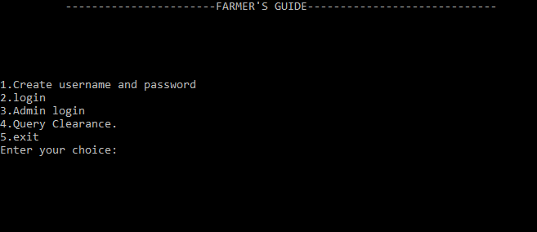 **Fig.5.1**

Above screenshot is the main page which appears as soon as the program is run.

**10**

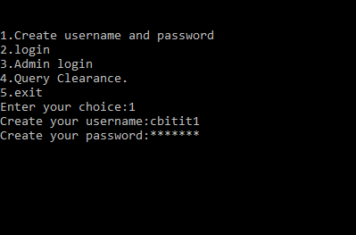

**Fig.5.2**

Above screenshot displays the creation of the username and password .

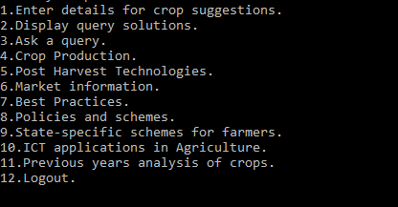

**Fig.5.3**

Above screenshot displays the page after loggin in with the respective username and password.

**11**

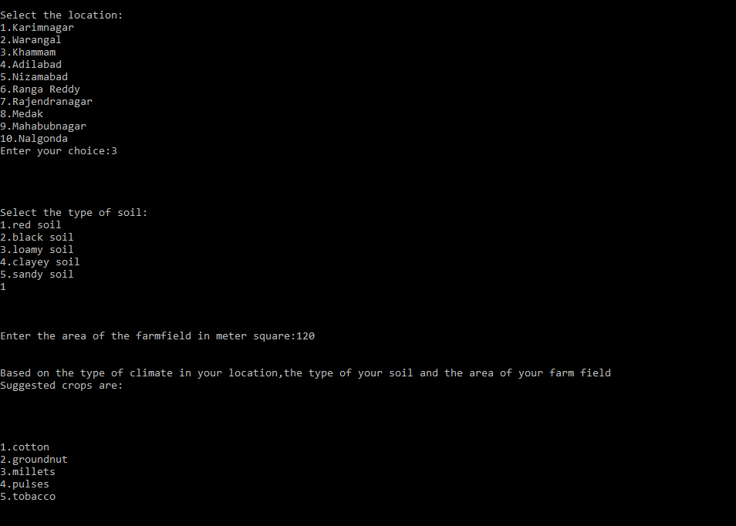

**Fig.5.4**

Above screenshot displays the page when option 1 is selected from the login page and it suggests the suitable crops.

**12**

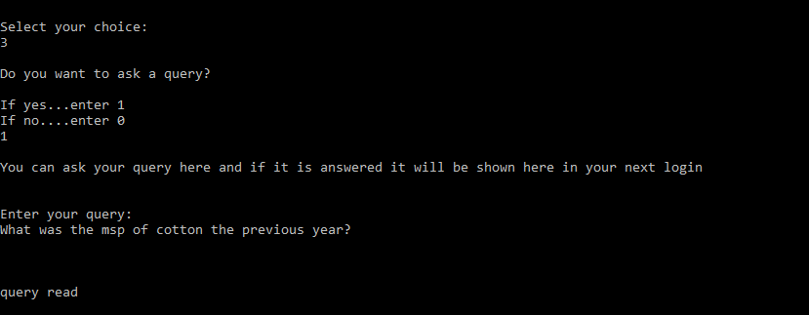

**Fig.5.5**

Above screenshot displays the ask a query option from the login page.

**13**

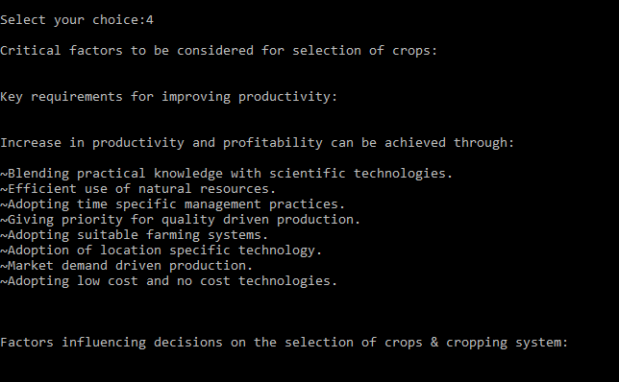

**Fig.5.6**

Above screenshot indicates the information regarding crop production.

**14**

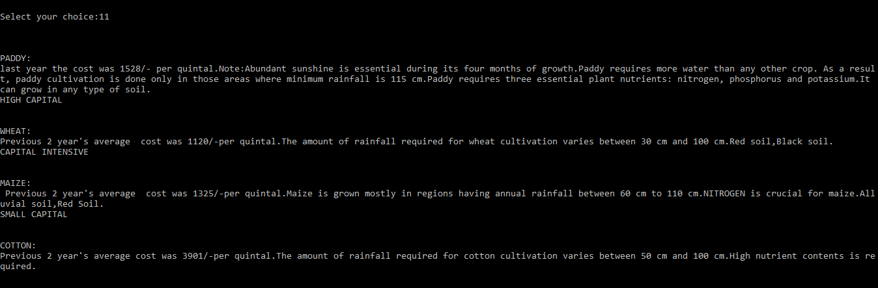 **Fig.5.7**

Above screenshot indicates the information of previous year statistics of crops.

**15**

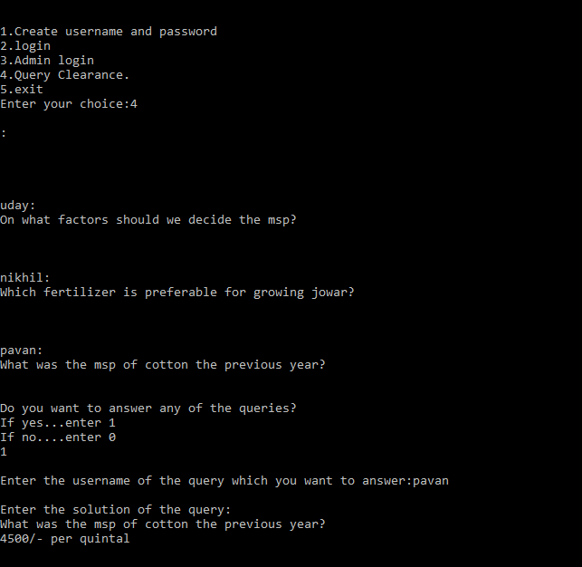

**Fig.5.8**

Above screenshot indicates the main page query clearance module where you can answer the

queries without even logging in. It means the admin can answer the query or any of the

farmers internally can give the solution of that query.

**16**

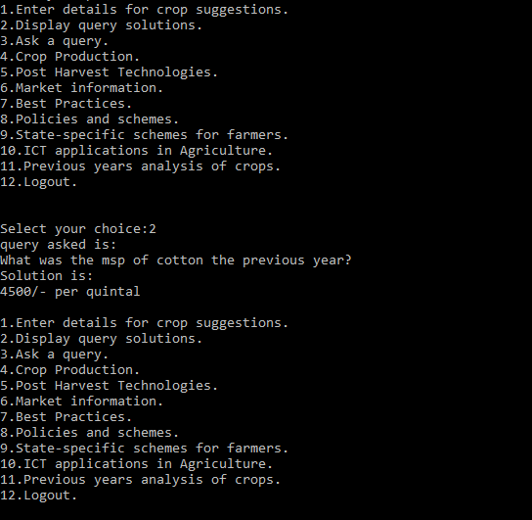

**Fig.5.9**

Above screenshot indicates the display query solution option’s outcome from their respective

login, where he can view the solutions of all the queries that he has asked.

**17**

**6**. **CONCLUSION & FUTURE SCOPE**

Our project farmer’s guide is completely coded in C++ using OOPS concepts, file concepts, data structures for efficient storage of data and retrieval of the data. It is completely user friendly and provides high security to the details of a farmer, thereby providing the information regarding crop production, post harvest technologies, market information, policies and schemes, state specific schemes for farmers, ICT applications in agriculture etc.

This project can mainly be enhanced in two ways :

1. The weather information can directly be linked through the satellites to our project and therefore the crops can be suggested more precisely based on the information.
2. The information regarding the solutions of their queries, policies and schemes in their states, etc. can be sent as a text message to their mobile phones.

**18**

**BIBLIOGRAPHY**

1. <http://vikaspedia.in/agriculture>

**19**